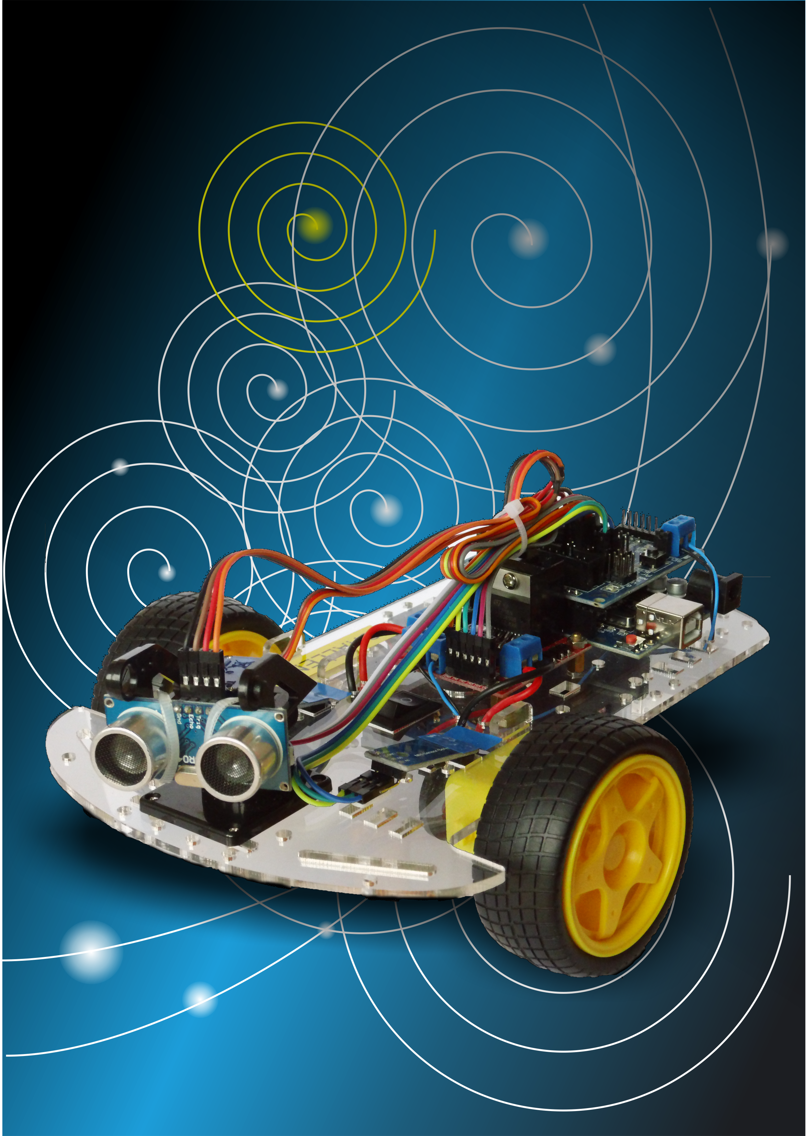

Autonomous Robot Challenge

Playbook

Jaap Daniëlse   
Autonomous Robot Challenge Playbook V0.1 - October 2017

# Colophon

©Jaap Daniëlse 2017  
Published under GNU Free Documentation License version 1.3 (GNU FDL)  
The Arduino Sketches referred from this document are published under the GPL3 License (shareware)

# Introduction

This playbook is intended to provide a guideline to organize a robot challenge as a set of corporate events for software developers and other IT professionals.

The idea is to build a simple autonomous robot able to perform simple tasks and compete over an assigned task the robot has to perform.  
The first event was organized for Wolters Kluwer GPO in the fall of 2016 over two locations, Deventer and Alphen. The build evenings were organized as separate events. The Challenge evening was a joint event over two locations using video connections to create a joint competition.

This documents tells how we organized the events and our experiences executing them.

### Kit

The main kit is bought as one item but unfortunately not complete enough to build a working robot from. The extra items needed are listed further on. I will ask the supplier if it is possible to create a kit containing all items needed.

When building this robot remember that is not a kit made by a big company that can only be built the right way and tested many times. In this kit the components sort of fit together, but you can definitely build it wrong. When building you are actually engineering your own robot and you have to get it to work.

Also be aware that components may be defective. They are affordable and that means sometimes quality is a bit poor. Over the 50 kit I provided I had about 5 components that were missing or defective. In a few cases I could fix them easily in the other cases the supplier sent replacements.

### Licence

I licensed The documentation under GNU FDL and the Software under GNU GPL3 this means both are available for personal and commercial use and may be used to create your own version and improvements. The Improvements however should be contributed back.

The software is intended as a starting point for your own development and you do not need to contribute this back. But if you improve the core then please do.

I would appreciate it if you let me know how things went.

j.danielse@gmail.com

Jaap Daniëlse, September 2017

# Robot Challenge

## Developer lab’s

As part of a series of developer lab’s we decided (after as small survey to assess the interest in the subject) to organize a dev lab building a small robot and another competing amongst each other in programming the robots to achieve a task.

The enthusiasm for this subject was much bigger than we expected ending up with over 50 participants.

## Robot

We developed a simple but powerful robot kit based on a Arduino Uno compatible microcontroller board. The chassis comes from a readily available kit that also contains motors, wheels and a battery case. Other components are a motor shield to drive the motors, speed sensors and a distance sensor.

Adding some mounting materials and wiring the complete kit ordered in China costs approximately

€ 23,- (not including import tax).

The resulting robot is small but impressive. It “knows” where it is going and how far it has turned and it can “see” using the ultrasonic distance sensor. Enough basic capabilities to tackle different challenges.

## Own contribution

To keep the cost of the event within limits and filter those who were really interested we asked a financial contribution of the participants of € 15,- . This proved to be a good idea.

# Planning the build

Because the components were ordered separately in China and assembled into kits by ourselves we needed to plan the robot build evening more than two months ahead.

We asked commitment from the participants beforehand an added a few extra kits as reserve and to accommodate late “arrivals”.

# Ordering components

Our components were all ordered from the Chinese firm Bangood: [www.banggood.com](http://www.banggood.com)

Who (so far) has lived up to its promises.

To spread risks we ordered packages of components for 5 robots each with a day between.

In most cases there are discount deals available containing sets of 5 or more components.

Since we are ordering really cheap components there is a real chance there will be faulty ones.

You can get these replaced but probably not in time.

We recommend ordering 1 reserve kit for every next 10 kits ( for 25 order 28).

The prices in China tend to vary al little depending on exchange courses and availability of components. The prices mentioned were taken from the Bangood site in Euro’s March 17th

2017.

Since march 2017 a more complete robot kit became available. This still needs additional components. They are listed below.

The kit:

DIY L298N 2WD Ultrasonic Smart Tracking Moteur Robot Car Kit For Arduino **€15,09**

For 1 robot €15,09/kit)

<https://www.banggood.com/DIY-L298N-2WD-Ultrasonic-Smart-Tracking-Moteur-Robot-Car-Kit-For-Arduino-p-1155139.html?rmmds=search>

The other parts:

*3Pcs 40P 20cm Female to Female Dupont Jumper Jump Cable Wire For Arduino***€3,45**

To connect all components to the sensorshield/arduino.

For 18 robots ( you need 2x3 wires - speed sensor per robot) (€0,19/kit)

<http://www.banggood.com/3Pcs-40P-20cm-Female-to-Female-Dupont-Jumper-Jump-Cable-Wire-For-Arduino-p-1033590.html>

*3Pcs 40P 30cm Female to Female Dupont Jumper Jump Cable Wire For Arduino***€1,77**

To connect the ultrasonic sensor to the sensorshield/Arduino.

For 10 robots ( you need 1x4 wires distance sensor per robot) (€0,18/kit)

<https://www.banggood.com/30cm-40pcs-Female-To-Female-Breadboard-Wires-Jumper-Cable-p-90154.html?rmmds=detail-left-hotproducts>

*50pcs M3 10mm Brass Female Threaded Hex Standoffs Spacer Nut DIY PCB Parts* **€2,74**

To mount the motor board and the Arduino to the robot chassis

For 12 robots (only available per 50) (You need 4 per robot) (€0,22/kit)

<http://www.banggood.com/50pcs-M3-10mm-Brass-Female-Threaded-Hex-Standoffs-Spacer-Nut-DIY-PCB-Parts-p-1007519.html>

*100Pcs M3 Bolts Stainless Steel Screws Button Head Socket Cap 10 Size (6 mm.)* **€3,04**

To use with the standoffs (above)

For 12 robots (only available per 100) (you need 8 per robot) (€0,24/kit)

<http://www.banggood.com/100PcsM3-Bolts-Stainless-Steel-Screws-Button-Head-Socket-Cap-10-Size-p-952124.html>

*10Pcs LM393 Speed Sensor Detection Speed Module For Arduino* **€9,43**

De detect the wheel movement

For 5 robots (you need 2 per robot) (€1,88/kit)

<http://www.banggood.com/10Pcs-LM393-Speed-Sensor-Detection-Speed-Module-For-Arduino-p-1052105.html>

*100pcs 100X2.5mm Nylon Cable Core Wire Zip Tie Strap Black/White* **€1,05**

To tie all connecting leads together.

For 25 robots (you need 4 per robot)(€0,04 / kit)

<https://www.banggood.com/100pcs-100X2_5mm-Nylon-Cable-Core-Wire-Zip-Tie-Strap-BlackWhite-p-988026.html?rmmds=search>

*DANIU 5 Meter Black Silicone Wire Cable 10/12/14/16/18/20/22AWG Flexible Cable* (20AWG) **€2,13**

For 25 robots (you need app. 20 cm per robot)(€0,09 /kit)

To connect the motor board to the SensorShield/Arduino

<https://www.banggood.com/DANIU-5-Meter-Black-Silicone-Wire-Cable-10121416182022AWG-Flexible-Cable-p-1170293.html?rmmds=search>

*Blue 3m 8/10/12/14/16/18/20/22/24/26 AWG Silicone Wire SR Wire* (20AWG**) €2,48**

For 15 robots (you need app. 20 cm per robot) (€0,16 / kit)

To connect the motor board to the SensorShield/Arduino

<https://www.banggood.com/Blue-3m-8101214161820222426-AWG-Silicone-Wire-SR-Wire-p-1087222.html?rmmds=search>

*2X 1.5V AA Battery Holder Case Enclosed Box With Wires 10pcs* **€2,42**

Extra battery holder. Unfortunately the robot will not work on 4 batteries.

For 10 robots (1 per robot) (€0,25/kit)

<https://www.banggood.com/2X-1_5V-AA-Battery-Holder-Case-Enclosed-Box-OFFON-Switch-With-Wires-10pcs-p-1064329.html?rmmds=search>

Also a set of Alkaline AA batteries (6 per robot) from a local store. Approximately **€1,50** per robot

Solder (Tin Lead Rosin core 0.8 mm (one roll will do**) €2,24**

<https://www.banggood.com/DANIU-100g-63-37-Tin-Lead-Rosin-Core-0_5-2mm-Flux-Reel-Welding-Line-Solder-Wire-p-989139.html?rmmds=detail-top-buytogether-auto>

Buy locally:

*Insulation tape* (one small role is more than enough)

*Double adhesive tape* (one small role is more than enough)

# The first event (building)

## Testing components

The components especially the boards are cheap and can have problems.

On the first event in Deventer I had not tested the components and we ran in to loads of problems which eventually came down to a short circuit between the motor shield (different from the current one) and the Arduino board. But on the evening itself I did not find this out so there seemed to be a lot of defective components.

For the second evening in Alphen I tested all boards motors and found a few defective components (one ultrasonic sensor and one motor board). This made the evening much smoother and finding faults easier because I knew the components were tested.

It is inevitable some participants will run into problems during the build evening. Using the test software, a multi meter and a bit of reasoning you should be able to solve those.

## Preparing Kits

I collected all components for each kit in a bag (you’ll receive plenty of bags from the shipments)

This makes getting started so much easier. In the build instruction (made by me) is a list of components.

## Doing a test build

I strongly recommend building a robot beforehand and experience yourself if trouble arises.

## Planning

We started with the initial signup for the first event 2 month before to have enough time to order all components and have some slack if something goes wrong.

The invitation folder we used is available as a pdf. You can make your own version.

The actual event was planned from 16:30h. until 21:00 hours. With the help of facility management in preparing the room. At 18:00h we had some Pizza (founded by the company) and of course refreshments.

On the first session we simply started building which did not always work out right.

On the second session we started with a presentation telling what to expect and how things work.

This helped in the understanding. The presentation is available with the other documentation.

## Software

For the software development the standard Arduino IDE.   
I made a test program to see if all components have been connected all right. There is also a ChallengBotHelloWorld program. The locations and descriptions can be found in the manual.

## Soldering

One of the more tricky operations is the soldering.

It would be great to have someone experienced available to assist the unexperienced.

For 25 people we had 4 soldering stations which was more than enough.

We had facility management cover the smoke detectors so they would not go of.

Also had the tables where the soldering took place covered with plates (supplied by facility) so they would not get burned.

## Tools and extra materials

Soldering irons and solder (1 set per max 8 participants)

Wire cutters (one per soldering set)

Box cutters (for stripping wires (One per soldering set)

Screwdriver (Cross and torx (for the m3 torx screws) if possible more than one of both)

(Ask participants to bring a small screwdriver themselves.)

Multi meter

Isolation tape

Double adhesive tape

Extra wire

Extra dupont wires

Extra batteries

# Second event (the challenge)

## Arena’s

The arenas were built from 15 cm x 229 cm planks made of chipboard. Screwed together using pieces of pinewood. We used two arena’s on each location. The camera pole prove (still shown) proved useless and was omitted.

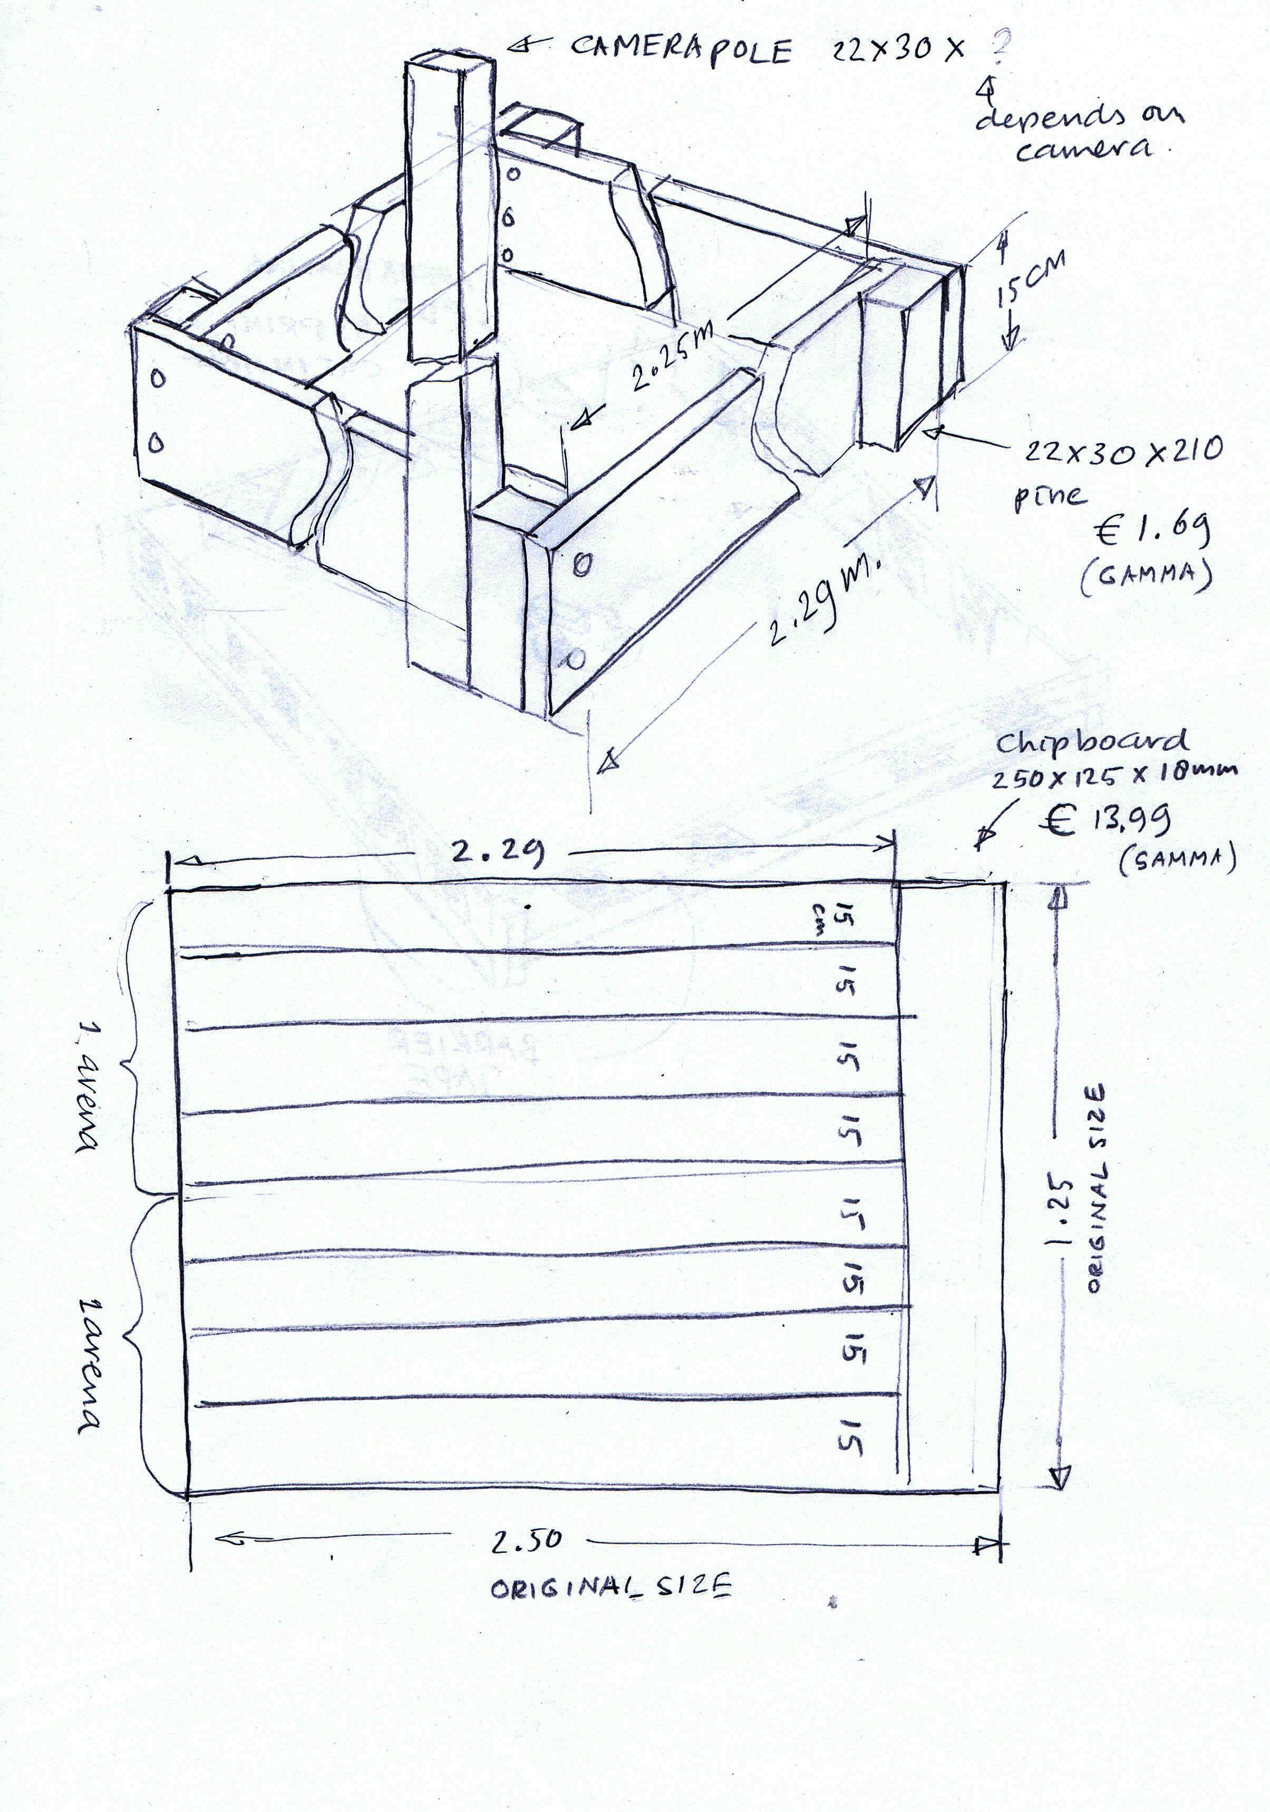

The Arena was decorated with barrier tape and printed border decorations (see doc)

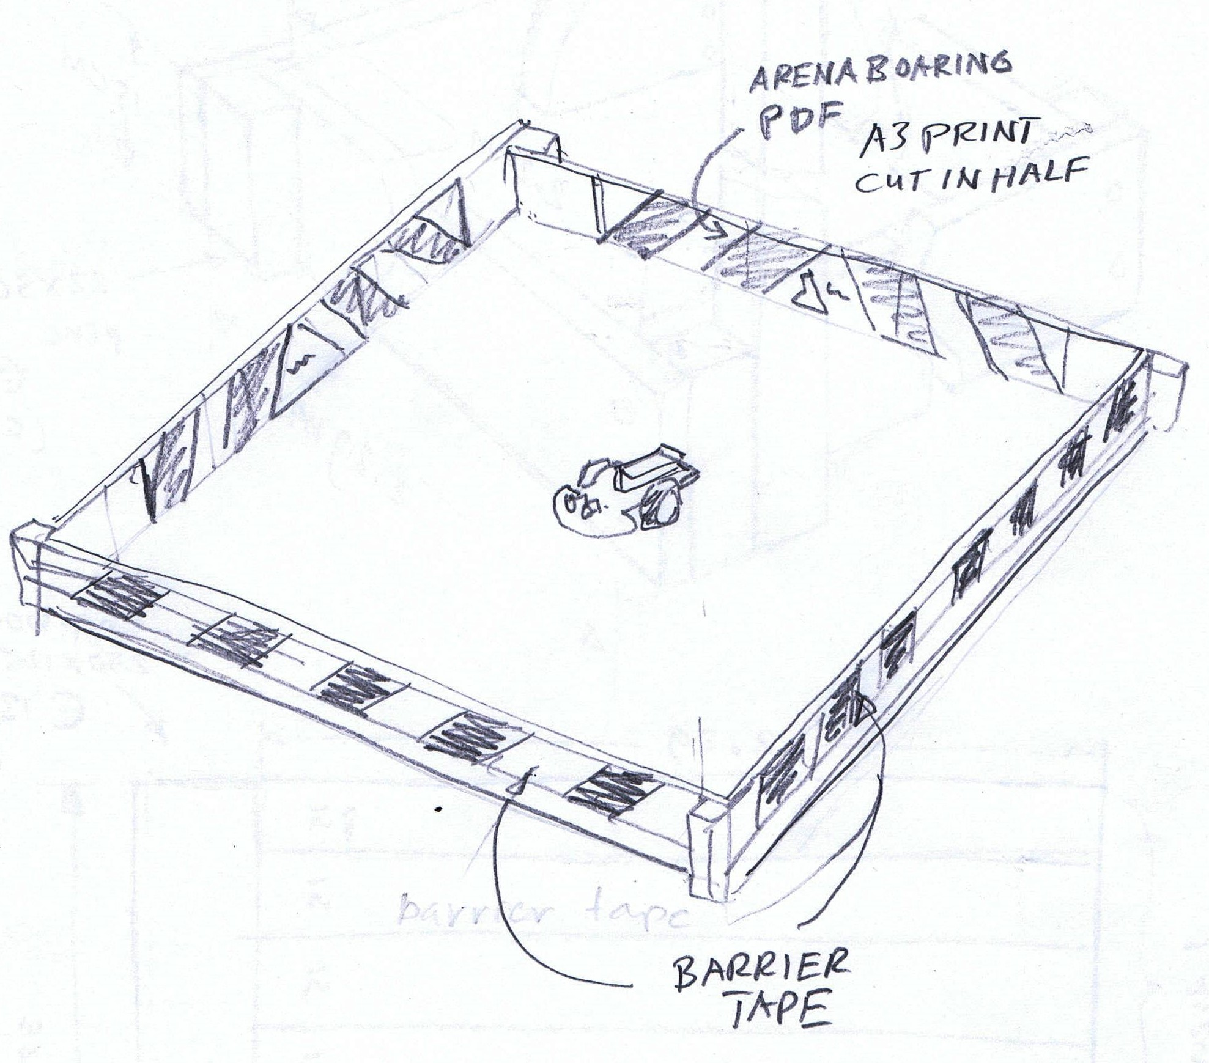

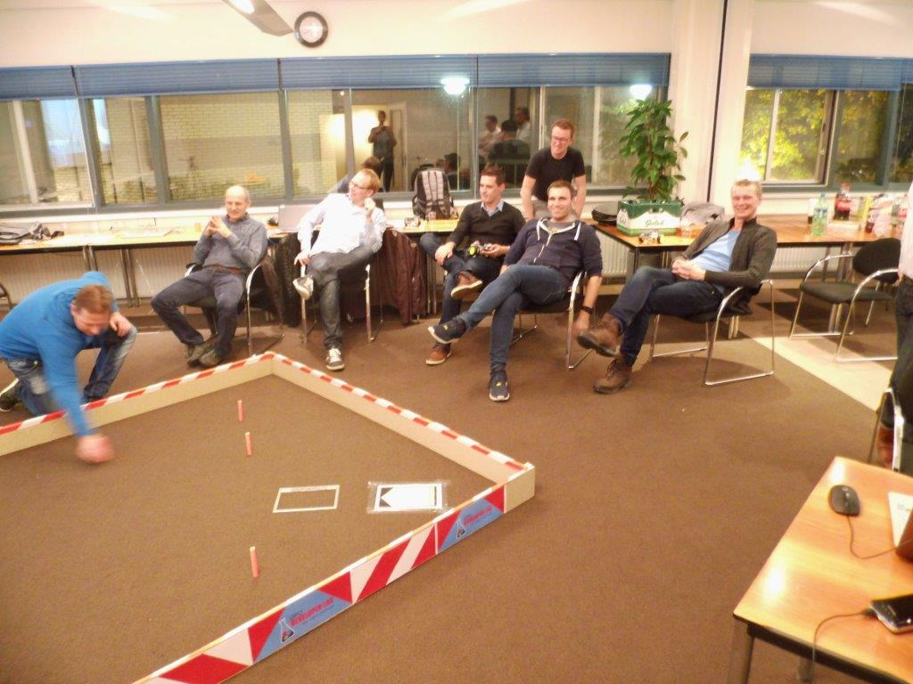

The targets were made of plastic pipe approx. 13 cm high and 2 cm diameter.

All contesters got one as part of the kit. For the challenge we painted them neon pink.

The launch pad was printed (see pdf) and taped on the floor.

## Planning

The challenge session was planned approximately 2 month after the build session.

The challenge is to knock over 5 targets within an area surrounded by “walls” as quickly as possible without hitting the walls. You gain points for knocking over targets but loose points for hitting the walls. It was allowed to enter both as a team and as an individual.

You will find a more elaborate description in the flyer we used. See pdf.

It was allowed to develop your software at home and practice in the arena’s but on the evening itself there would also be time to develop.

We used the same time schedule as for the build evening. We started at 16:30h and ended around 21:00h with pizza at 18:00h which worked fine.

We had all tools including soldering irons and new batteries available.

We had every one develop and practice till about 20:00 and started with the contest after this.

The contest has a time limit of 3 minutes. Only one of our teams stayed within this limit.

We originally planned to have pools and then a final but this proved unpractical.

We simply had one entry after another (2 for teams) and this worked fine. There was enough difference in points to mark a first second and third place.

## Challenge Rules

The Challenge is to knock over 5 targets within an area surrounded by “walls” as quickly as possible without hitting the walls. You get points for knocking over the targets but loose points for hitting the walls. There is a time limit but time left after having knocked over all targets grants you extra points.

**Chalenge groups**

* A chalenge group will consist of a group of contestants or teams across the two locations.
* Each challenge group will have an arena in both Alphen and Deventer.
* Runs will be alternating in Alphen and Deventer.
* There will be a video link between the arenas of each challenge group.

**Teams**

* Working in teams is encouraged.
* A team may enter 2 robots or one robot 2 times (of the 2 runs the best run counts).
* If a team wins all members win.

**Points**

* Knocking over a target 10 points
* Touching the wall -1 point.
* At the start a robot has 30 points for time.
* For every 6 seconds 1 point is subtracted.
* If all targets are knocked over the remaining time points will be added to the score.
* If a robot gets stuck against the walls it may be restarted at the launch pad. This will cost 5 points. Time will continue.

**Arena’s**

* The arena will be square 2.25 x 2.25 m. with 15 cm high walls.
* There will be 5 targets 12.5 cm high, 1.6 cm across (like the one you got).
* Targets are placed at least 20 cm from the edges and at least 20 cm from each other.
* The launch pad will be in one corner 20 cm from the sides facing the opposite corner.
* There will be a time limit of 3 minutes.
* If all targets are knocked over time will stop.
* Each arena will have a referee. Robot modifications need to be approved by the

referee.

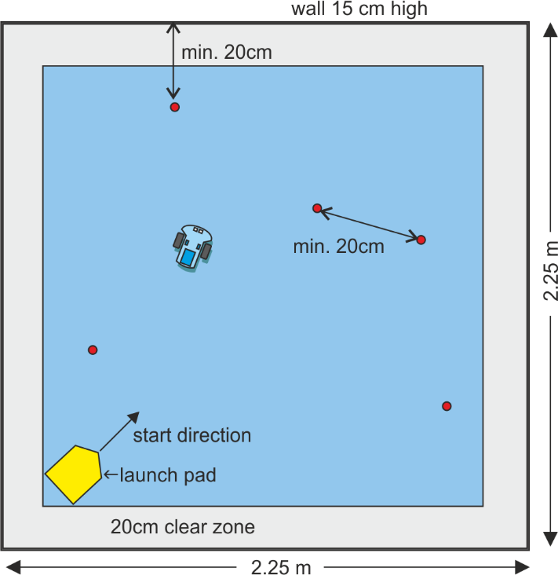

**Modifications**

* The robot must consist of the original components.
* Extra weight may be added to increase stability.
* You are encouraged to “pimp” your robot and make it pretty, funny or cool. The additions can have no functional impact on the challenge. (The robot may not be longer, wider or have extra moving parts to knock over targets).
* There will be an extra prize for the coolest, prettiest or funniest robot.

*Unforeseen matters are decided by the referees.*

**Competition (over locations)**

If you have enough teams participating, a competition might be fun. We did a competition over two locations using a video link shown on a beamer. This sort of worked but a second link for the organization is a must.

* A chalenge group will consist of a group of contestants or teams across the two locations.
* Each challenge group will have an arena in each loaction.
* Runs will be alternating in locations.
* There will be a video link between the arenas of each challenge group.
* Each arena will have a referee.

# Document list

#### Main

ChallengeBot Playbook.docx This document.

ChallengeBot Instructions Vx.x.docx Building instructions for the robot.

I recommend distributing the Instructions as online publication PDF (can be exported from MS Word).

#### Promotion

ChallengeBot Poster.docx Poster. (Text can be altered)

ChallengeBot BuildFlyer.docx Flyer to promote the build evening. (Text can be altered)

ChallengeBot ChallengeFlyer.docx Flyer to promote the challenge evening. (Text can be altered)

I recommend distributing the promotion material as online publication PDF (can be exported from MS Word).

#### Support

ChallengeBot ArenaBoarding.docx Document with the arena boarding. (Text can be altered)

LaunchPad.png Launch pad image.

#### Sources

*ChallengeBotTest.ino*

1. ChallengeBotTest.ino
2. DistanceSensor.ino
3. MotorControl.ino
4. Servo.ino
5. SpeedSensor.ino

*ChalengeBotHelloWorld*

1. ChallengeBotHelloWorld.ino
2. DistanceSensor.ino
3. Drive.ino
4. MotorControl.ino
5. Servo.ino
6. SpeedSensor.ino

I licensed the documentation under GNU FDL and the Software under GNU GPL3 this means both are available for personal and commercial use and may be used to create your own version.

# Support

If possible I am prepared to advice on both preparation and execution of the event. Contact me!

[J.danielse@gmail.com](mailto:J.danielse@gmail.com)